# Attending online lectures with Teams: student guide

Your lecturer will be running live online sessions using the web conferencing system Teams. This guide explains how to access the system and actively participate.

## Before the session

Copy the meeting link from your Moodle page.

## To join the session

Paste the meeting link into your internet browser.

Depending on your browser and whether you have downloaded the Teams app, you will see one of the following screens.

If you have already downloaded the Teams app, you might be asked to select Microsoft Teams and Open link. If you haven’t downloaded the app then click Get the Teams app.

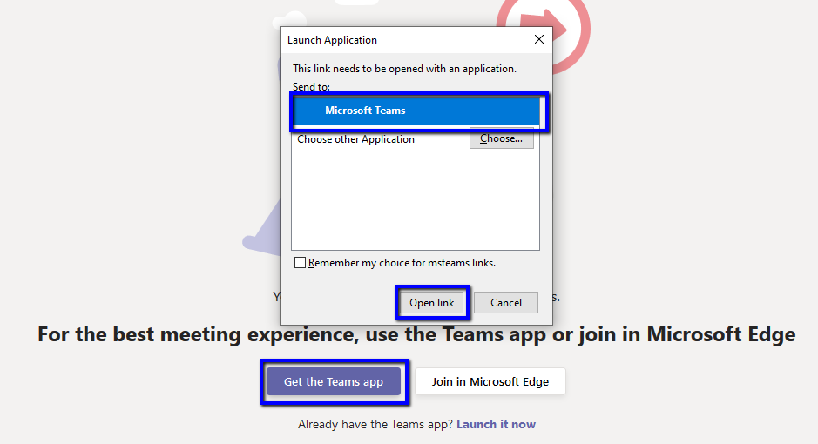

Or the screen might look like this. Either download or open the Teams app.

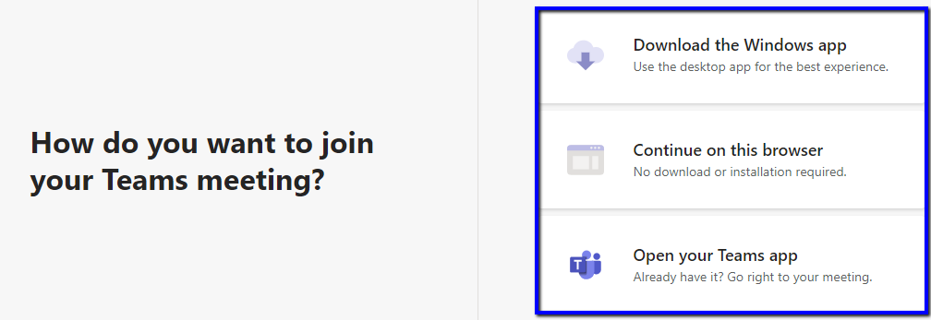

You may also see a further pop up message. Click Open Microsoft Teams.

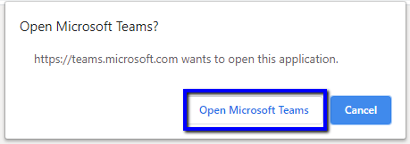

You will be asked to log in with your City account. Enter your City email address and click Sign in. Enter your City password and click Sign in.

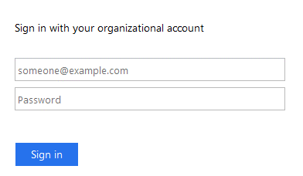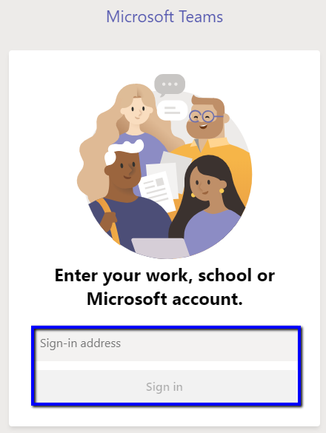

Ensure your microphone and camera are switched off and click Join now.

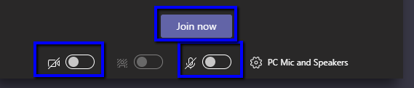

## During the session

Hover towards the bottom of your screen when you want to see your meeting controls.

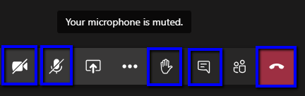

Your lecturer will explain how they would like you to participate at the start of the session, this may be in one or more of the following ways.

* Using the chat: you may be asked to respond to or ask questions by typing in a chat box. Click  to open the chat box.
* You can raise your hand  to request the attention of the lecturer or to give feedback.
* Audio: your lecturer may invite you to speak during the session. Click the  to switch on your microphone. Ensure you are in a quiet environment and remember to mute your microphone as soon as you have finished speaking, to avoid background noise and feedback.
* Webcam: your lecturer may invite you to switch on your webcam. Click the  to turn on your webcam. Ensure you are in a quiet, well-lit environment with a neutral background. Where available, add a virtual background by clicking on the 3 dots and select Show background effects. Select your chosen background and click Apply.

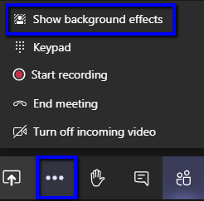

## After the session

The session will be recorded wherever possible and the recording will be added to the module page on Moodle as soon as possible afterwards.

## Additional Support

If you encounter technical issues and require further support, please contact your Course Officer in the first instance.